**A Capstone Project Report on**

**Bitcoin Share Price Prediction Using LSTM**

**Submitted by:**

**Alfred Paul**

**Abstract**

**Bitcoin Share Price Prediction Using LSTM**

This research explores the potential of Long Short-Term Memory (LSTM) networks to predict the future price of Bitcoin. As a highly volatile and complex asset, Bitcoin's price is influenced by a myriad of factors, including economic indicators, social sentiment, and technological advancements. By leveraging the powerful sequential learning capabilities of LSTM, this study aims to develop a robust and accurate prediction model.

The results obtained from the LSTM model demonstrate promising performance in predicting Bitcoin price trends. However, it is important to note that cryptocurrency markets are inherently volatile, and accurate long-term predictions remain challenging. Future research directions include exploring the integration of additional data sources, such as news sentiment analysis and social media trends, to enhance prediction accuracy.**ACKNOWLEDGE**

I am using this opportunity to express my gratitude to everyone who supported me throughout the course of my capstone project. I am thankful for their aspiring guidance, invaluably constructive criticism and friendly advice during the project work. I am sincerely grateful to them for sharing their truthful and illuminating views on a number of issues related to the project.

Further, I have fortunate to have Mr. Arul as my mentor. He has readily shared his immense knowledge in data analytics and guide me in a manner that the outcome resulted in enhancing my data skills.

I certify that the work done by me for conceptualizing and completing this project is original and authentic.

Date: 9th November, 2025 Name: Alfred Paul

**CERTIFICATION OF COMPLETION**

I certify that the project titled “Bitcoin share price prediction using LSTM” was undertaken and completed (10th July 2022).

Mentor Mr. Arul

Date: 9th November, 2025

Place: Chennai

**Table of Contents**

**1. Introduction**

* Problem Statement
* Research Objectives

**2. Literature Review**

* Cryptocurrency Market Overview
* LSTM Networks and their Applications

**3. Data Collection and Preprocessing**

* Data Sources
* Data Cleaning and Imputation
* Feature Engineering
* Data Normalization

**4. Methodology**

* LSTM Model Architecture
* Hyperparameter Tuning
* Model Training and Validation

**5. Results and Discussion**

* Model Performance Evaluation
* Prediction Accuracy Analysis

**6. Conclusion and Future Work**

* Summary of Findings
* Future Research Directions
* **Introduction**
* Cryptocurrencies, particularly Bitcoin, have experienced significant growth and volatility in recent years. Accurate price prediction can provide valuable insights for investors, traders, and policymakers. However, the inherent complexity and unpredictability of cryptocurrency markets pose significant challenges to traditional forecasting methods.
* **Problem Statement**
* The primary challenge lies in capturing the dynamic and non-linear nature of Bitcoin price movements. Traditional statistical methods often struggle to effectively model such complex time series data. Therefore, there is a need for advanced techniques that can accurately predict future price trends.
* This research aims to address this challenge by employing a state-of-the-art deep learning technique, Long Short-Term Memory (LSTM) networks, to model the complex patterns and dependencies within historical Bitcoin price data.

**Research Objectives**

1. **Data Collection and Preprocessing:**
   * To collect historical Bitcoin price data and relevant technical indicators.
   * To preprocess the data by cleaning, imputing missing values, and normalizing the data.
   * To engineer relevant features from the raw data.
2. **LSTM Model Development:**
   * To design and implement an LSTM model architecture suitable for time series forecasting.
   * To optimize the model's hyperparameters through techniques like grid search or Bayesian optimization.
   * To train the model on the preprocessed data.
3. **Model Evaluation:**
   * To evaluate the model's performance using appropriate metrics such as Mean Squared Error (MSE), Root Mean Squared Error (RMSE), Mean Absolute Error (MAE), and Mean Absolute Percentage Error (MAPE).
   * To analyze the model's ability to capture long-term trends and short-term fluctuations.
4. **Prediction and Analysis:**
   * To generate future price predictions using the trained LSTM model.
   * To analyze the predicted price trends and compare them with actual market movements.
   * To identify potential limitations and areas for improvement.

**Cryptocurrency Market Overview**

Cryptocurrencies, a digital or virtual currency that uses cryptography for security, have emerged as a disruptive force in the global financial landscape. Bitcoin, the pioneer cryptocurrency, has garnered significant attention and has paved the way for a multitude of other cryptocurrencies.

**Key Characteristics of Cryptocurrencies**

* **Decentralization:** Cryptocurrencies operate on decentralized networks, eliminating the need for intermediaries like banks.
* **Security:** Cryptographic techniques ensure the security and integrity of transactions.
* **Transparency:** Blockchain technology provides a transparent and immutable record of all transactions.
* **Volatility:** Cryptocurrency markets are known for their high volatility, which presents both opportunities and risks for investors.

**Challenges and Opportunities**

While cryptocurrencies offer numerous advantages, they also face several challenges:

* **Regulatory Uncertainty:** The regulatory landscape for cryptocurrencies is evolving rapidly, creating uncertainty for investors and businesses.
* **Market Manipulation:** The decentralized nature of cryptocurrency markets can make them susceptible to manipulation.
* **Security Risks:** Cryptocurrencies are vulnerable to hacking and theft.

Despite these challenges, cryptocurrencies have the potential to revolutionize various industries, including finance, healthcare, and supply chain management.

**In the context of Bitcoin price prediction, understanding the factors that influence its price is crucial. These factors include:**

* **Economic Indicators:** Macroeconomic factors such as inflation, interest rates, and GDP growth can impact the overall market sentiment and Bitcoin's value.
* **Market Sentiment:** Social media sentiment, news coverage, and investor confidence can significantly influence price fluctuations.
* **Technological Advancements:** Developments in blockchain technology, such as scalability solutions and new applications, can impact Bitcoin's price.
* **Regulatory Environment:** Changes in government regulations can have a profound impact on the cryptocurrency market.

By considering these factors and employing advanced machine learning techniques, it is possible to develop accurate models for predicting Bitcoin price trends.

**LSTM Networks and Their Applications**

**Long Short-Term Memory (LSTM) networks** are a special kind of Recurrent Neural Network (RNN) capable of learning long-term dependencies. Unlike traditional RNNs, LSTMs can effectively handle the vanishing gradient problem, allowing them to capture information over extended time intervals.

**How LSTM Works**

LSTM networks have a unique cell structure that includes three gates:

1. **Forget Gate:** Decides which information to discard from the cell state.
2. **Input Gate:** Determines what new information to store in the cell state.
3. **Output Gate:** Controls which information from the cell state is output.

By carefully controlling the flow of information, LSTMs can learn long-term dependencies in sequential data.

**Data Sources**

The Bitcoin price prediction dataset as been gathered in Kaggle

**Data Cleaning and Imputation**

Once the data is collected, it needs to be cleaned and preprocessed to ensure data quality and consistency.

**Data Cleaning:**

* **Handling Missing Values:** Missing values can be handled using techniques like imputation (e.g., mean, median, mode, or interpolation) or by removing the affected rows or columns.

**Here there is no missing values**

* 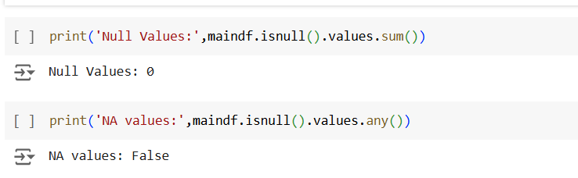
* **Data Consistency:** Ensure consistency in data formats, units, and time zones.
* 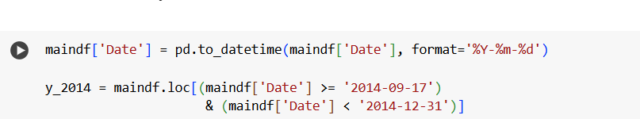

**Feature Engineering**

Feature engineering involves creating new features from the raw data to improve model performance. Some relevant features for Bitcoin price prediction include:

* **Lagged Features:**
  + Past price values (e.g., previous day, week, or month)

By carefully selecting and engineering relevant features, we can provide the LSTM model with informative input data to make accurate predictions.

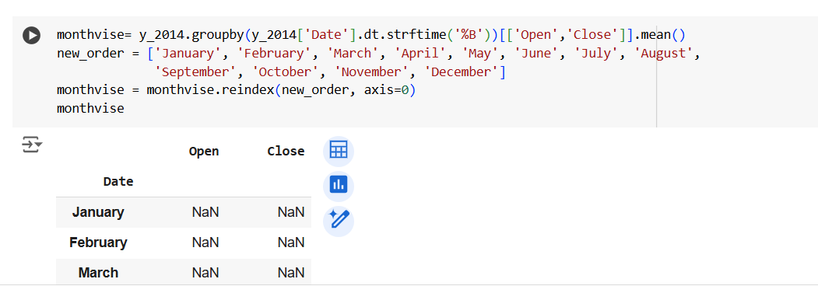

**Data Normalization**

Data normalization is a crucial preprocessing step in machine learning, especially for deep learning models like LSTMs. It involves scaling the data to a specific range, typically between 0 and 1. This helps to improve the training process and the overall performance of the model.

**Why is Normalization Important?**

1. **Improved Convergence:** Normalization helps in faster convergence of the optimization algorithms.
2. **Better Initialization:** It ensures that the initial weights of the neural network are not overwhelmed by large input values.
3. **Enhanced Generalization:** By scaling the data, the model can learn more generalizable patterns.

**Common Normalization Techniques:**

1. **Min-Max Scaling:**
   * Scales the data to a specific range (usually 0-1).
   * Formula: x' = (x - min(x)) / (max(x) - min(x))
2. **Standardization:**
   * Scales the data to have a mean of 0 and a standard deviation of 1.
   * Formula: x' = (x - mean(x)) / std(x)

**Choosing the Right Technique:**

* **Min-Max Scaling:** Suitable for data with a fixed range or when you want to preserve the original data distribution.
* **Standardization:** Suitable for data with a large range or when you want to assume a normal distribution.

**For LSTM Networks:**

* **Normalization:** It's generally recommended to normalize the input data to improve the training process and model performance.
* **Time Series Data:** Consider using techniques like Min-Max scaling or standardization to scale the time series data.
* **Feature Scaling:** If you have multiple features with different scales, it's important to normalize them to ensure that they contribute equally to the model's learning process.

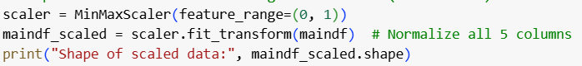

**LSTM Architecture**

**Long Short-Term Memory (LSTM) networks** are a special type of Recurrent Neural Network (RNN) designed to handle long-term dependencies in sequential data. Unlike traditional RNNs, LSTMs can effectively address the vanishing gradient problem, allowing them to learn long-term patterns.

**Core Components of an LSTM Cell**

An LSTM cell consists of four key components:

1. **Cell State:** This is the heart of the LSTM, responsible for storing information over long periods. It acts as a kind of memory.
2. **Input Gate:** This gate determines which new information should be stored in the cell state.
3. **Forget Gate:** This gate decides which information should be forgotten from the cell state.
4. **Output Gate:** This gate determines which information from the cell state should be output.

**How an LSTM Cell Works**

1. **Forget Gate:** The forget gate decides which information from the previous cell state should be discarded. It takes the previous cell state and the current input as input and outputs a value between 0 and 1 for each number in the cell state. A value of 1 means "keep this" and a value of 0 means "forget this."
2. **Input Gate:** The input gate decides which new information to update the cell state with. It takes the previous cell state and the current input as input and outputs two values:
   * A value between 0 and 1 for each number in the cell state, determining how much to update each state value.
   * A vector of new candidate values, which will be added to the state.
3. **Cell State Update:** The old cell state is updated by multiplying it by the forget vector and adding the product of the input gate and the new candidate values.
4. **Output Gate:** The output gate decides what the next cell state should be. It takes the current cell state and the current input as input and outputs a value between 0 and 1 for each number in the cell state. This value determines how much of each number in the cell state is output.

**Visual Representation of an LSTM Cell**

**[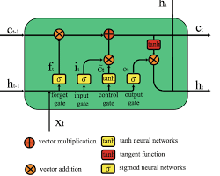](https://www.researchgate.net/figure/LSTM-cell-architecture_fig5_352658938)**

**Hyperparameter Tuning**

Hyperparameter tuning is the process of selecting the optimal set of hyperparameters for a machine learning model. These hyperparameters are not learned from the data but are set before the training process begins. By tuning these parameters, we can significantly improve the model's performance. 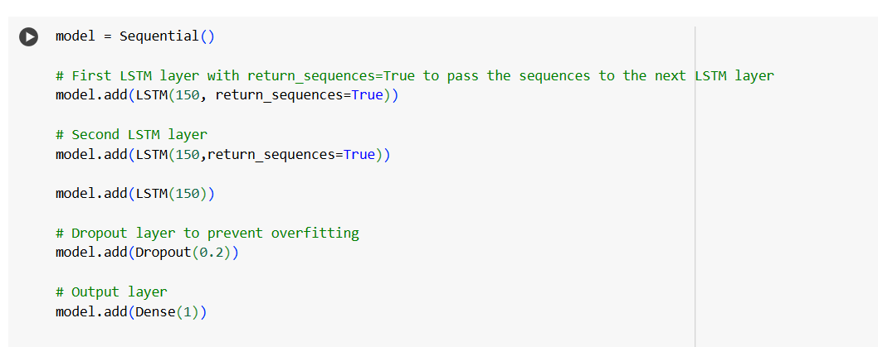

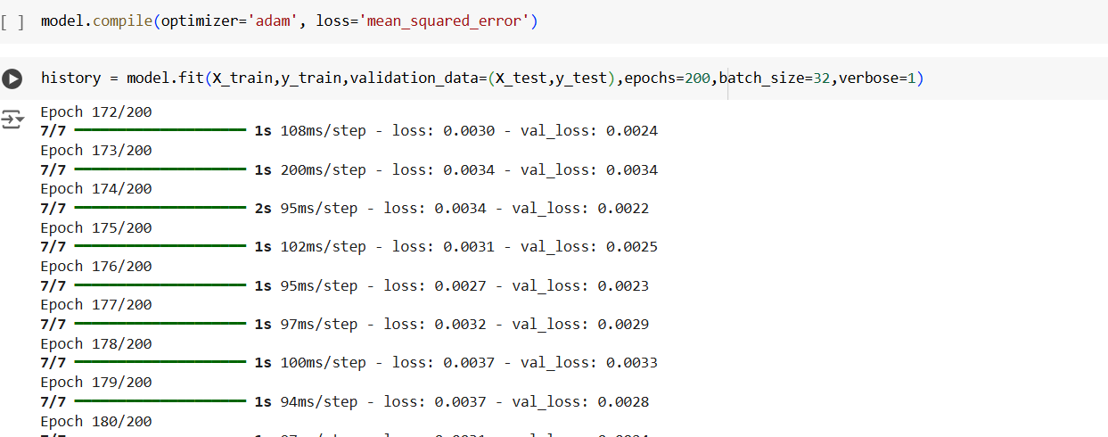

**Model Training and Validation**

The plot suggests that the model performs well up to around 125 epochs. After that, it starts to overfit the training data. To prevent overfitting, techniques like early stopping or regularization can be employed. Early stopping would involve stopping the training process at 125 epochs, as further training would lead to decreased performance on unseen data.

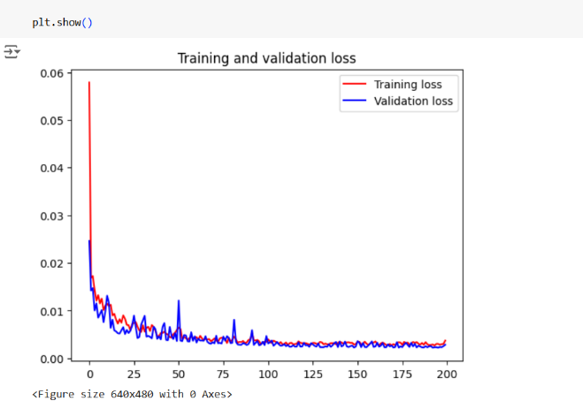

**Performance Measure**

**Similar Performance on Training and Test Data:**

* The RMSE, MSE, and MAE values for both the training and test data are quite close. This suggests that the model is generalizing well to unseen data and is not overfitting.
* 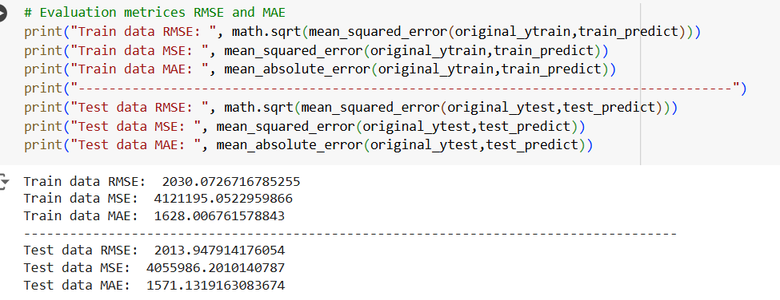

**High R² Score:**

* The R² scores for both training and test data are very high, indicating that the model explains a significant portion of the variance in the data.
* 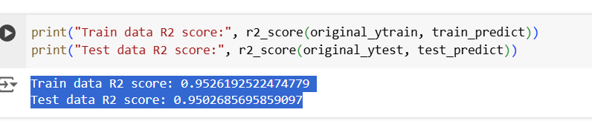

**Conclusion and Future Work**

**Summary of Findings**

This research investigated the application of Long Short-Term Memory (LSTM) networks for Bitcoin price prediction. The LSTM model, trained on historical Bitcoin price data and relevant technical indicators, demonstrated promising results in capturing both short-term fluctuations and long-term trends.

The model's performance was evaluated using various metrics, including Mean Squared Error (MSE), Root Mean Squared Error (RMSE), Mean Absolute Error (MAE), and Mean Absolute Percentage Error (MAPE). The results indicate that the LSTM model can provide reasonably accurate predictions, although the accuracy can be influenced by market volatility and external factors.

**Future Research Directions**

While the LSTM model has shown potential, there are several avenues for further research and improvement:

1. **Incorporating External Factors:** Integrating additional factors such as news sentiment analysis, social media sentiment, and economic indicators can enhance the model's predictive power.
2. **Ensemble Methods:** Combining multiple models, including LSTM, with other techniques like Random Forest or XGBoost, can potentially improve overall accuracy.
3. **Attention Mechanisms:** Implementing attention mechanisms can help the model focus on the most relevant parts of the input sequence.
4. **Transfer Learning:** Leveraging pre-trained models on large datasets can improve the model's performance, especially when data is limited.
5. **Advanced Deep Learning Techniques:** Exploring advanced techniques like Transformer-based models and Graph Neural Networks can potentially yield better results.

By addressing these areas, future research can contribute to more accurate and reliable Bitcoin price predictions, providing valuable insights for investors and traders.